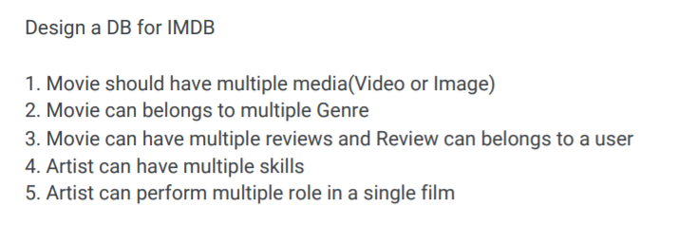

Tables:

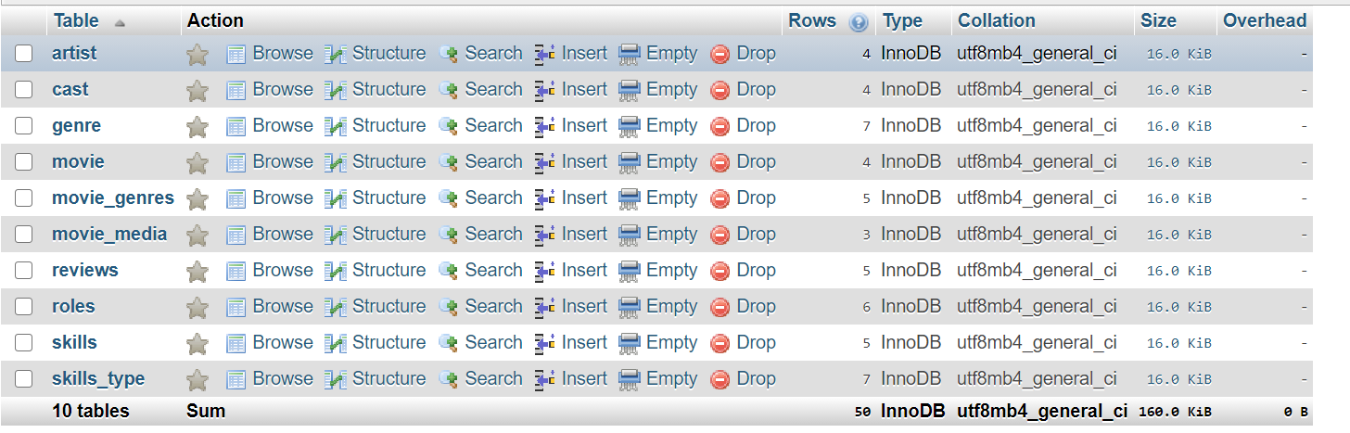

Queries:

List all media of a particular film.

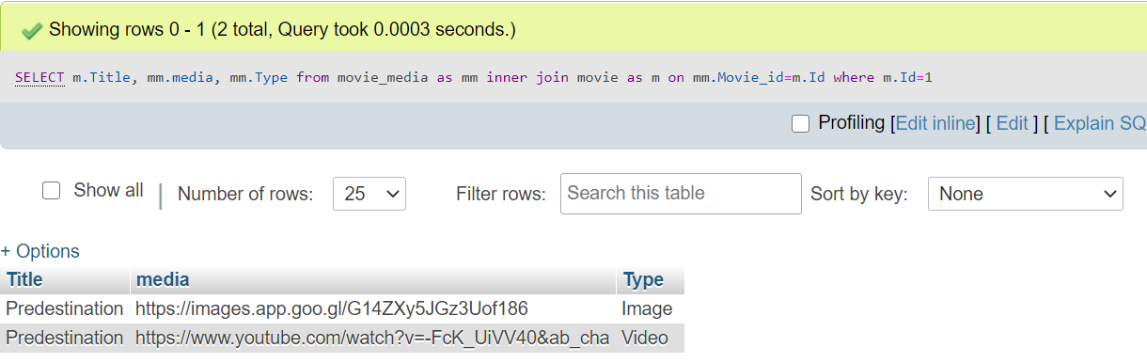

List all media and reviews of a particular film.

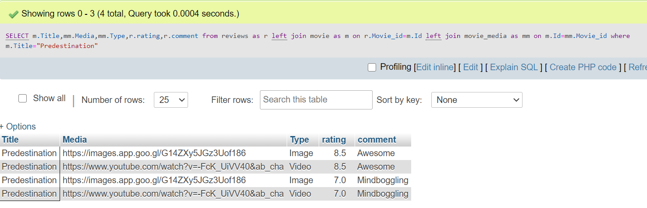

List all cast along with roles and artist of a particular film

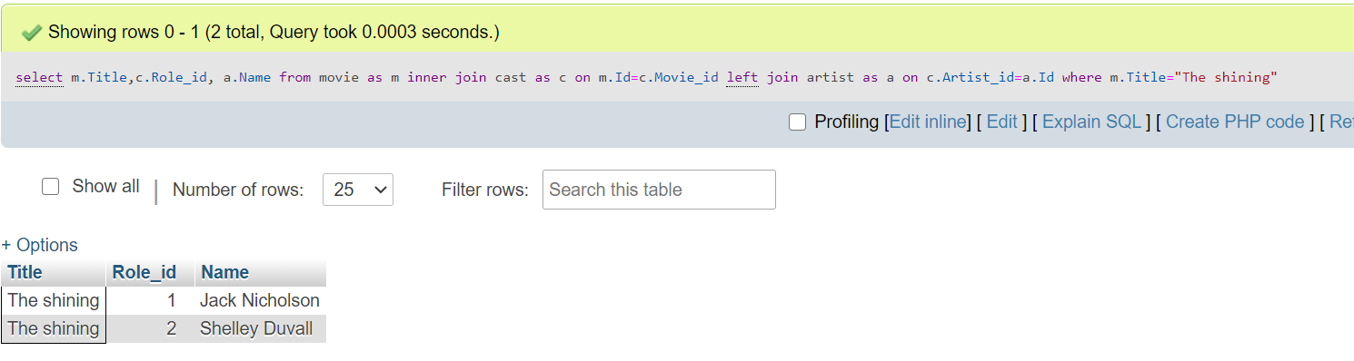

List all the reviews given by particular user

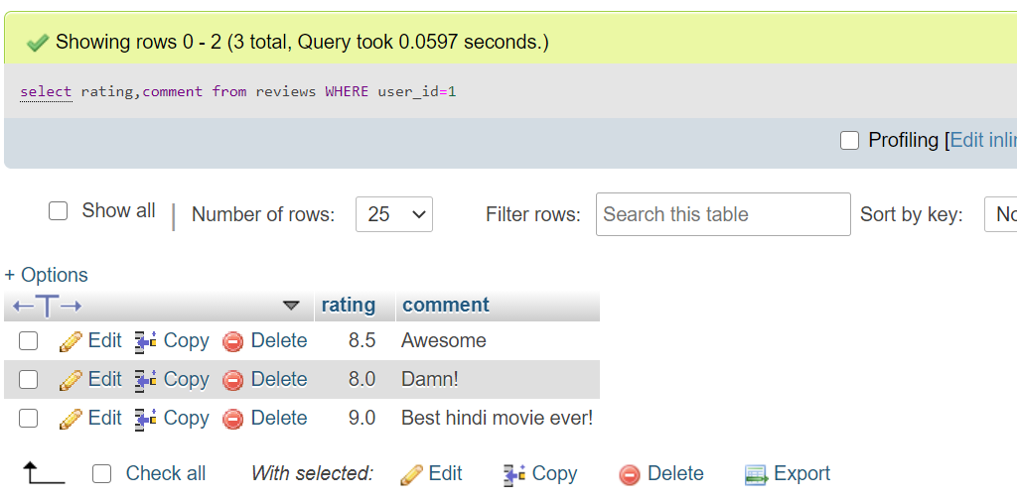

List all the skills of a particular Artist

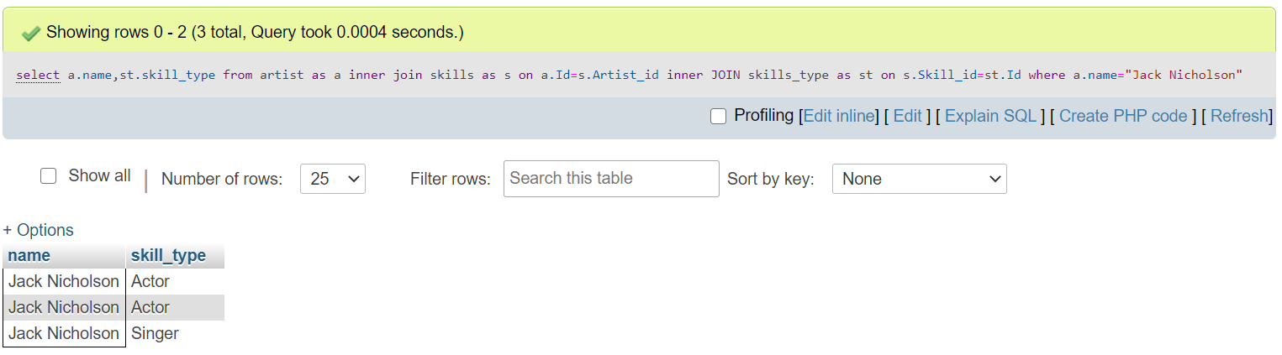

List all the roles performed by particular artist

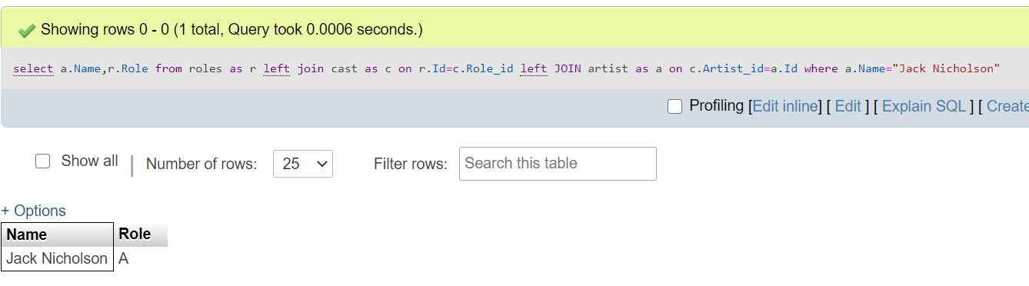

Create a view for getting the overall rating of all the movies.



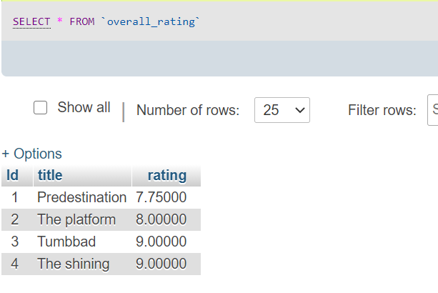

Create a view to list all actors with their skills.



